General Course Information

Course Title | Algebra 2 Honors
Description | Algebra 2 Honors begins with an in-depth study of equations and inequalities, and then moves into the study of linear equations and functions. Students will explore matrices and learn how to apply them as a method to solve linear systems. This course examines advanced topics such as quadratic functions, factoring, polynomial functions, rational exponents and radical functions. An introduction to exponential, logarithmic and rational functions will also be presented. Throughout the course, students will gain experience with graphing calculators and view them as a tool to help solve real world problems.
Room Number | 136
Faculty Name | Mrs. Pollman
Contact Information  (Phone/email) | 517-545-0828 ext. 136  spollman@kwoods.org
Course Website | pollman.kwoods.org

Introduction

Mathematics Vision Statement
Mathematics is the science of p_______ and relationships. It is the language and l____ of our technological world. Mathematical power is the ability to explore, to conjecture, to r_____ logically and to use a variety of mathematical methods effectively to solve problems. The ultimate g___ of mathematics education is for all students to develop mathematical power to participate fully as a citizen and worker in our contemporary world.

Helpful information about instructor expectations
This course will follow the framework outlined by the Michigan Merit Curriculum and the ACT College Readiness Standards. These benchmarks are assessed at the state level on the Michigan Merit Exam (MME) and the ACT College Entrance Exam which is given to all Michigan students. In addition, the Common Core State Standards will direct the instruction, activities and assessments in this course in order to develop mathematically proficient students.
Mathematically proficient students-
- Make sense of problems and persevere in solving them.
- Reason abstractly and quantitatively.
- Construct viable arguments and critique the reasoning of others.
- Model with mathematics.
- Use appropriate tools strategically.
- Attend to precision.
- Look for and make use of structure.
- Look for and express regularity in repeated reasoning

Comment to students~ I am really excited about this school year and want all students to be successful! Students are expected to use class time wisely and should plan to spend time at home completing assignments that are not finished in class. It really is up to you to choose to do those things which will help you be successful in this course. Since math builds one skill upon another, it is very important to keep up with daily assignments. If you are having trouble with the assignments, please SEE ME so that we can make arrangements for some extra help.
Extra help is available!
- I will have a “Math Support” Advisory for students who need extra help during the school day.
- After school help is typically available every Wednesday until 5:00 pm.*
*If there is a scheduling conflict, I will notify students in advance of an alternate day to stay after.

Prerequisite knowledge/skills for success in this course

Mastery Level | Prerequisites: Open to students who have successfully completed Algebra I and Geometry.  - Work habits: Students will be able to work effectively independently and in groups.  - Academic integrity: Students will act honestly and ethically in their work.  - Study skills: Students will adhere to assignment deadlines.
Familiarity Level | - Intellectual openness: Students will use mathematical skills and technological tools to solve real world problems.

Course Materials

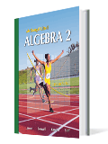
Textbook- Algebra 2 (2008) Larson, Boswell, Kanold, & Stiff
- Students will be assigned a textbook at the beginning of the school year and will be required to complete a textbook agreement form which has been signed by a parent/guardian. Students will be expected to bring this textbook to class on a daily basis. Students will be responsible for their assigned book throughout the school year and will be charged a replacement fee if the book is lost or damaged. The school is not responsible for books left behind in the classroom.

Algebra 2- Online Textbook Information
- Go to: activate.classzone.com
- To access the online products, students will use the product specific Activation Code listed below.
ACTIVATION CODE: 2611269-170 Product Name: Algebra 2 – eEdition
If you have any trouble accessing your online products, please feel free to call the Technical Support Hotline. (800-727-3009)

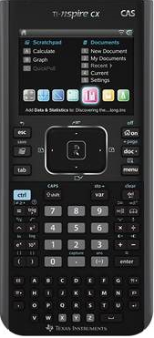
Calculator- TI-Nspire CX Handheld from Texas Instruments
- The TI-Nspire CX is the latest in learning technology from Texas Instruments. This handheld device allows students to visualize mathematical concepts and to take an interactive role in their learning. Students will be assigned an Nspire CX to use during class. These handhelds may not leave the classroom, since they need to be shared among all classes. Students are strongly encouraged to purchase the Nspire or Nspire CX for use at home. There are a limited number of Nspires which may be checked out by students on a nightly basis, but there is not a guarantee that one will be available for all students who need to sign one out. Any student who wishes to sign out a
TI-Nspire must have an agreement form that is signed by a parent/guardian on file with Mrs. Pollman.

TI-Nspire CX Handheld Key Features
- Full-color, thin design- high resolution LCD
- Real-world images- use digital images or your own photos for real world connections
- Rechargeable battery- expected to last 2 weeks on a single charge
- Dynamic graphing features- save work like on a computer

Grading

Your semester grade will be determined as follows:  Formative Assessments.....20%  Summative Assessment.....60% Semester Exam.....20%  Formative Assessments-  Daily assignments & activities  Summative Assessments-  Chapter quizzes, tests & projects | KWHS follows the following grading scale:  A = 95-100 (4.0)  A- = 90-94 (3.7)  B+ = 87-89 (3.3)  B = 83-36 (3.0)  B- = 80-82 (2.7)  C+ = 77-79 (2.3)  C = 73-76 (2.0)  C- = 70-72 (1.6)  F = below 70 (0.0)

Daily Assignment Policy
1. Assignments should be done neatly. The process of solving a math problem is just as important as the final answer. Therefore, you must show your work!
2. Assignments that are not completed during class time are expected to be finished as homework before the date it will be collected, usually Thursday of each week. On the due date, students must turn in an assignment that shows their best effort. If students feel that they need additional time to master the material, they must make arrangements with Mrs. Pollman to get help outside of class time. After the student has met with the teacher regarding the assignment and has demonstrated mastery of the topic, the grade will be adjusted. However, full credit will not be given to work that is not complete on the due date.
3. It is the students' responsibility to make sure that they find out what they missed during their absence. Students should check the class assignment list for a listing of the topic and assignment and make sure that they pick up any handouts that they may have missed.
4. New this year! KWHS- Homework ‘Gift Certificates’. Students will be given three certificates per semester to turn in an assignment late with no questions asked. Use these slips wisely! Students may redeem the certificates for ‘extra credit’ at the end of the semester if they did not need to use it.
Summative Assessment Policy
- Quizzes & Tests~ Students will generally have one or two quizzes per chapter and one test at the end of each chapter. These tests will include the current material covered in the chapter as well as some review problems. If students are absent on a test day, they will be expected to make-up the test on the day they return to school.

- Retakes~ New this year! KWHS- Request to Revise or Retest Generally, students are not allowed to retake a chapter quiz or test during class time. However, students may fill out a ‘Request to Retest’ form and make arrangements outside of class time to master the material and then, retest.

- Test Corrections~ Students will usually be given an opportunity to make test corrections for half credit on the day that tests are returned. Students are reminded that there is a difference between giving help and giving answers. Generally, only one class day will be allotted for test corrections. Beyond that, students must meet with the teacher outside of class time for corrections. If students score below 50% on a given test, they must make arrangements outside of class time to work on test corrections and demonstrate mastery before the adjusted grade will be posted.

Classroom Expectations

- Classroom Expectations- Students should come to class ready to learn. Students should respect the learning environment, including the people and property around them. Students will be given the opportunity to have food & drinks in the classroom if they prove that they can do so in a responsible manner. If this privilege distracts from the learning environment, it will be taken away.

- Beginning of Class- Be on time and in your seat with all required materials. ***Book, Calculator, Folder, Assignments, Pencil, Paper***
At the beginning of class, students will complete Math Starters or follow directions as given.
- Class Assignments & Activities~ Students will be expected to participate in classroom activities and to complete classroom assignments. Class assignments will usually be graded on effort and completeness. Assignments will generally be collected on a weekly basis. Students will sometimes be given the responsibility to check their own assignments in class.
- Handing in Work- Typically, students will hold on to their class assignments which will be collected once a week by the teacher . If directed to hand in work, students will use the blue tray at the front of the room with their block time labeled on it. Students turning in make-up work, should use the blue trays at the front of the room.

- End of Class- Students are expected to return all materials to their designated places and then return to their seats. Students will be dismissed by the teacher. All students must be seated before class will be dismissed!

- Finding out Course Grade- Students are encouraged to check MI-STAR in order to track their grades. Students will be given notification of their current grade average in the course at least one week before official progress reports. Students may also make arrangements to see me outside of class to find out grade information. Time will not be taken out of class on a daily basis to discuss individual student grades.

Schedule

On this page, students will find an outline of the topics that will be covered in this course. Please keep in mind that this timeline may need to be adjusted from time to time to best meet the needs of the class.

Time Frame | Topics | Assessments
September | - Chapter 1- Equations and Inequalities  - Nspire Technology Intro  - Math in the Real World | - Ch 1 Quiz (1.1 to 1.3)  - Ch 1 Test  - Writing- “Math in the Real World”
October | - Chapter 2- Linear Equations and Functions  - Regression Analysis-Linear  - Geometry Review | - Ch 2 Quiz (2.1 to 2.4)  - Ch 2 Test  - Ch 2 Reflection
November | - Chapter 3- Linear Equations and Matrices  - 21st Century Skills  - Geometry Review | - Ch 3 Quiz (3.1 to 3.3)  - Ch 3 Test  - Ch 3 Reflection
December | - Intro- Chapter 4- Quadratic Functions and Factoring  - Semester Exam Review  - Geometry Review | - Ch 4 Quiz (4.1 to 4.5)  - Semester Exam- Chapters 1-3
January | - Finish- Chapter 4  - ACT Content Standards  - Geometry Review | - Ch 4 Test  - Ch 4 Reflection
February | - Intro- Chapter 5- Polynomials and Polynomial Functions  - ACT Content Standards  - Geometry Review | - Ch 5 Quiz (5.1 to 5.4)  - Power Point Project
March  March | Testing- ‘College Entrance’ Exam  - Finish- Chapter 5  - Stock Market Game  - 21st Century Skills | - Ch 5 Test  - Ch 5 Reflection
April | - Chapter 6- Rational Exponents and Radical Functions  - Stock Market Game | - Ch 6 Quiz (6.1 to 6.4)
May | - Finish- Chapter 6  - Semester Exam Review  - Stock Market Game | - Ch 6 Test  - Stock Market Game Reflection & Analysis  - Semester Exam- Chapters 4-6

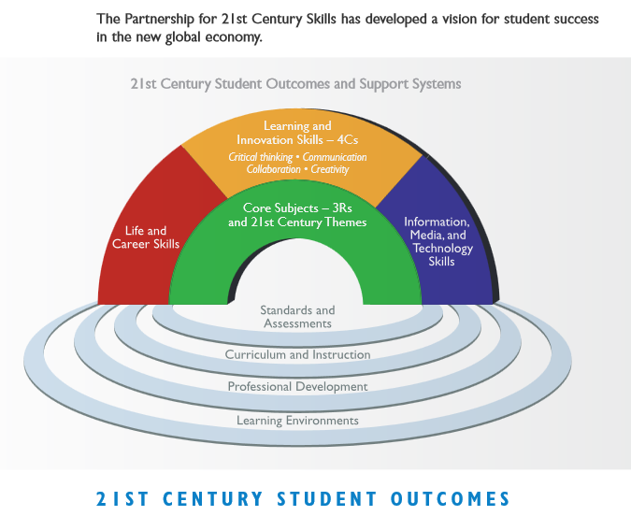

Essential Standards

- Students will be able to analyze functions using different representations including algebraic, graphical, numerical, or verbal.

Students will be able to build a function that models a relationship between two quantities.

Students will construct and compare linear, quadratic, and exponential models to solve real world problems.
- Students will use trigonometric concepts and basic identities to solve problems.
- Students will match graphs of basic trigonometric functions with their equations and model periodic phenomena with trigonometric functions.

Students will analyze data by using measures of central tendency and dispersion.

Students will understand statistics as a process for making inferences about population parameters based on a random sample from that population.

Students will use probability to evaluate outcomes of decisions.
 | Common Core Priority Standards- Descriptions
A-REI.2 | Understand solving equations as a process of reasoning and explain the reasoning.
A-REI.2 | Solve simple rational and radical equations in one variable, and give examples showing how extraneous solution may arise.
A-REI.11 | Represent and solve equations and inequalities graphically.
A-CED.1 | Create equations that describe numbers or relationships.
A-CED.2 | Create equations in two or more variables to represent relationship between quantities; graph equations on coordinate axes with labels and scales.
A-CED.4 | Rearrange formulas to highlight a quantity of interest, using the same reasoning as solving equations.
F-BF.1 | Write a function that describes a relationship between two quantities
F-BF.3 | Build new functions from existing functions.
F-IF.8 | Write a function defined by an expression in different but equivalent forms to reveal and explain different properties of the function.
F-LE.4 | For exponential models, express as a logarithm the solution to ab^{ct}=d where a, c, and d are numbers and the base b is 2, 10, or e; evaluate the logarithm
 | using technology.
F-BF.1 | Write a function that describes a relationship between two quantities

